**Math 120  
1.9 Distance and Midpoint Formulas; Circles**

# Objectives:

1. Find the distance between two points.
2. Find the midpoint of a line segment.
3. Write the standard form of a circle’s equation
4. Give the center and radius of a circle whose equation is in standard form.
5. Convert the general form of a circle’s equation to standard form.

# Topic #1: The Distance Formula

Calculating the distance between any two points in the plane is done by applying the Pythagorean Theorem. Consider the two points and in the coordinate plane:

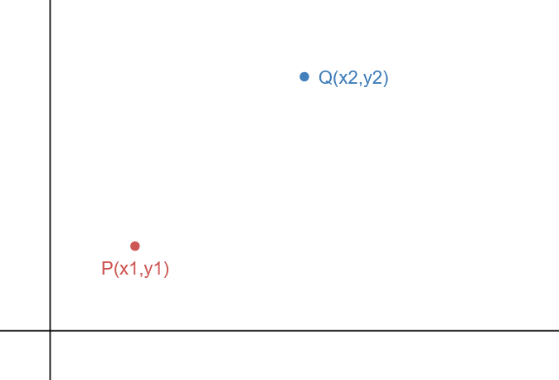 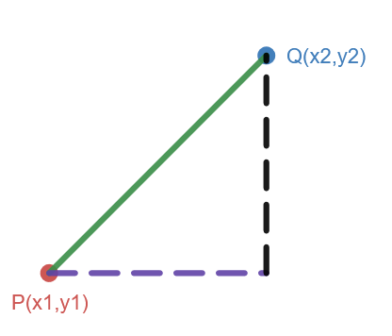

We can turn the points into a right triangle and the distance between the two points is the hypotenuse.

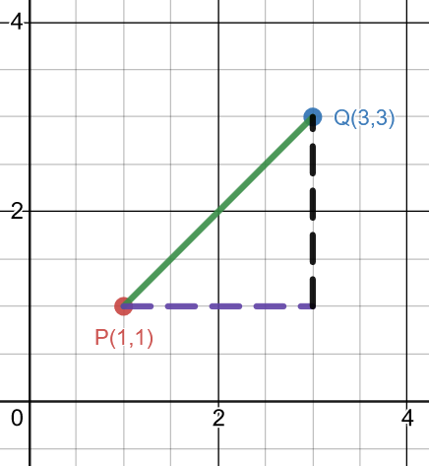Suppose we call the hypotenuse (which is the distance between the points) . The legs of the triangle are the horizontal and vertical distances.

In other words:

This gives the distance formula:

Suppose the points and are and – see diagram and complete worked out example.

Then the distance is

*Example #1* – Calculate the Distance between the Given Points

a) and

The two points give

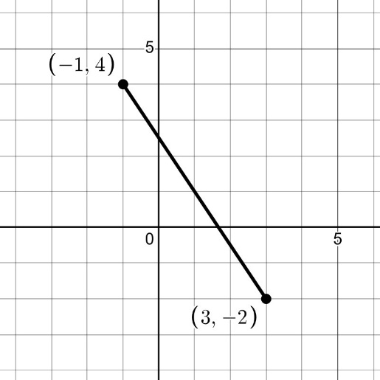Using the formula, we can calculate the exact distance and give a decimal approximation:

A right triangle is how we find the distance; the formula comes from the Pythagorean Theorem:

b)

Using the formula:

# 2 points in the plane with a midpointTopic #2: The Midpoint Formula

The midpoint between two points is the **_____________ value of the coordinate and the coordinates**; creating a new ordered pair.

The distances between each point and the midpoint are equal:

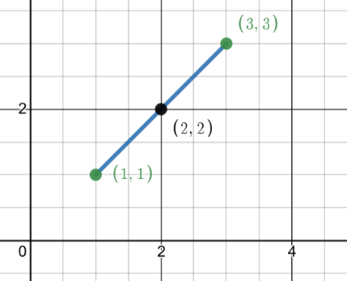By definition of average, the midpoint between two points is the ordered pair:

Suppose the points and are and

To find the midpoint, find the average of the x coordinate and the y coordinates:

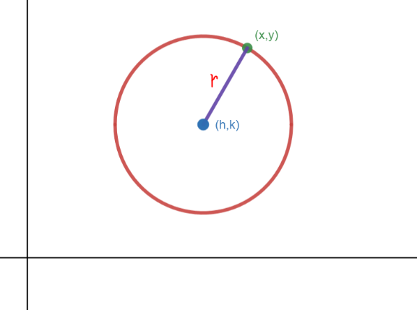 *Example #1* – Calculate the Midpoint between the Given Points:

1. )

# Topic #3: Equations of Circles in Standard Form

A circle has a fixed center.

All points on a circle have a fixed distance to the center, which is the radius.

Consider the circle with a center , a radius , and any point on the circle :

By the definition of a circle described above and the distance formula, the standard equation is:

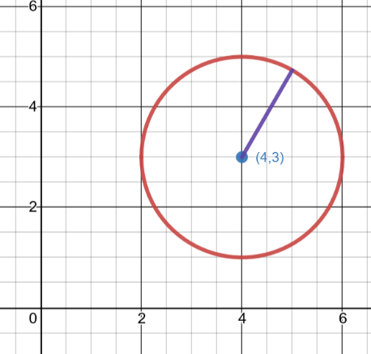

where is the center and is the radius of the circle.

Suppose the center of the circle is and the radius is

Then the equation is:

*Example #1* – Write the Standard Form of the Equation with the Given Center and Radius

a) Center: Radius: b) Center: Radius:

Using the standard form, write the equation: Using the standard form, write the equation:

# Topic #4: The Domain and Range of a Circle

Consider the equation of the circle:

By definition,

This tells us the center is ___________ and the radius is

Using the definition of a circle, we can find 4 convenient “corner” points by adding/subtracting units from the center along both the and -axis.

In other words, the corner points are all 2 units away from the center since this is the radius is .

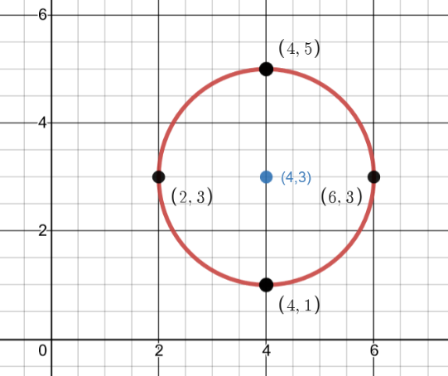Adding/subtracting along the x-axis:

Adding/subtracting along the y-axis:

Looking at the -axis, the domain is

Looking along the -axis, the range is

The midpoint of the corner points along each axis must be the center of the circle. The distance from any corner point to the center must be the radius of the circle (apply both formulas to confirm).

*Example #1* – Find the Center, Radius, Domain, and Range of the Circle

a)

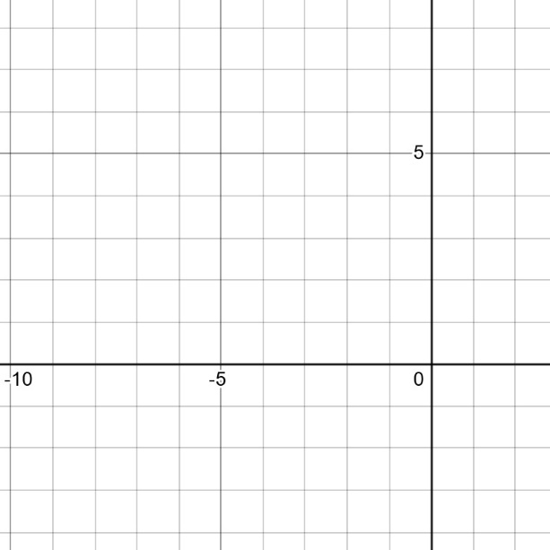

By definition,

This tells us the center is ___________ and the radius is

To find the **domain and range,** ___________________ by adding/subtracting __________________________

Adding/subtracting along the x-axis:

Adding/subtracting along the y-axis:

The domain is __________and the range is ________

b)

By definition,

This tells us the center is ___________ and the radius is

To find the **domain and range,** ___________________ by adding/subtracting __________________________

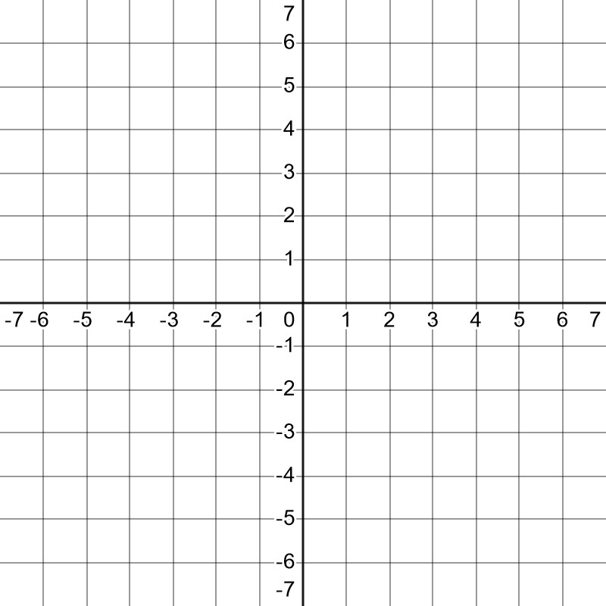Adding/subtracting along the x-axis:

Adding/subtracting along the y-axis:

The domain is __________and the range is ________

*Example #2* – Use the Conditions to Find the Equation of the Circle

A circle with points diametrically opposed is given; find its equation in standard form:

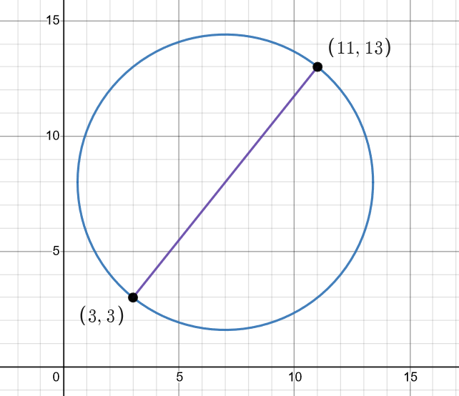

We need the __________________________________

The center is the_________________ of the opposing points:

The radius is the fixed **_____________________**between any point and the center:

With the equation is:

# Topic #5: Equations of Circles in General Form

The **general form** of a circle is:

In this form, we are not given the center and radius of the circle. To get this information, we must **_________________________**to put the equation into standard form:

Consider the equation:

This is in general form. To complete the square to get into standard form, first group and terms:

***Then, take half of the first power coefficients and square. Add to both sides of the equation:***

***Adding half of the first power coefficients and squaring creates perfect square trinomials, which you can factor to write the equation of the circle in standard form:***

This gives the center as and the radius as

*Example #1* – Find the Center and Radius of the Circle

a)

Group x and y terms and add half the coefficients of the first power terms to complete the square.

Factor to write the equation in standard form, and identify the center and radius of the circle:

b)

Group x and y terms and add half the coefficients of the first power terms to complete the square:

Factor to write the equation in standard form, and identify the center and radius of the circle: